Have a Go Activity Weekend

Free for young people aged 13 to 17 with a visual impairment

The Royal National College for the Blind (RNC)
Saturday 26 and Sunday 27 October 2019

Join us for a fun weekend!
- Try sports such as Goalball and VI football
- Art, music and drama
- Bowling, golf and lots more
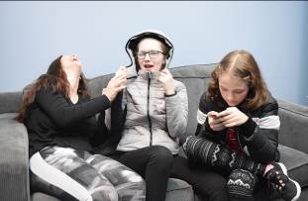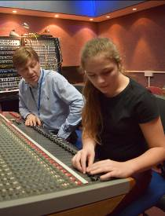

Free overnight accommodation for accompanying adults/siblings

“We love this place, it is so empowering for the young people. The support mixed with the encouragement to be independent and try new things is unique and very special.” Dawn, mother from Sheffield.

For more information and to request a booking form:
Call 01432 376 621
Email info@rnc.ac.uk

