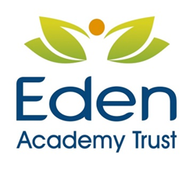


Teaching Assistant - Personal Specification

Essential | Desirable
Qualifications
QCF recognised relevant Level 2 | Working towards a relevant level 3 or at level 3
Knowledge:
Awareness of practices and procedures within education relating to the welfare, safety and education of children | Knowledge of other to young people services
General understanding of national/foundation stage curriculum and other basic learning programmes and strategies

Basic understanding of child development and learning

Relevant Experience:
Working with or caring for children young people | Working with or caring for children of relevant age
 | Working in a classroom setting
Skills:

Ability to self-evaluate learning needs and actively seek learning opportunities | Effective use of ICT to support learning
Ability to relate well to children and adults | Use of other equipment technology – video, photocopier
Able to work constructively as part of a team, understanding classroom roles and responsibilities and own position within these

James Rennie School is committed to safeguarding and promoting the welfare of children and young people and expects all staff and volunteers to share this commitment. Therefore, an enhanced DBS check including the barred list will be required for the successful candidate and other procedures and checks will be followed as laid out in our Safeguarding Policy.

