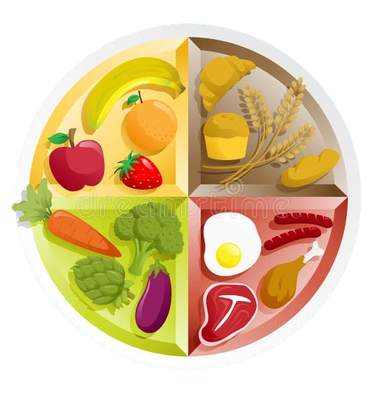


Week 2

 | Choice 1 | Choice 2 | Pudding
Monday | Cheese & Tomato Pizza served with Salad & Coleslaw | Tuna Roll served with Salad & Coleslaw | Chocolate Iced Sponge
Tuesday | Crispy Chicken served with Brown Rice & Mixed Veg | Oven Baked Jacket Potato served with Cheese & Salad | Iced Shortbread
Wednesday | Beef and Veg Pie served with Peas & Baby Carrots | Egg & Cress Baguette  Served with Carrot, Sultana & Beetroot | Iced shortbread
Thursday | Cumberland Sausage served with Mashed potato, Yorkshire Pudding & Beans | Oven Baked Jacket Potato served with Cheese & Beans | Anzac Biscuits
Friday | Breaded White fish served with Oven Chips & Peas | Chicken Burger served with  Chips & Peas | Golden Crispy
We offer a wide choice of healthy, nutritious, value for money meals.
Menus are varied and enjoyable every day of the week and the children have lunchtime fun with their friends.
Also available daily: Fresh Salad Selection, Fresh Fruit and Yoghurts.

