 | Marking Policy
November 2021 – Kris Williams (Head Teacher)
To be reviewed November 2023 or sooner

James Rennie School is an all age (3-19) Special School for pupils with severe or profound learning needs; The School is based in Carlisle and its catchment area stretches across the North of Cumbria. Our School’s philosophy is learning, believing and achieving for all our futures, we are governed by our one school rule we look after each other.

We wish to place the young people at our School in the best possible position for their next step away from James Rennie.

As such James Rennie places it pupils at the heart of its education, and so will work from that young person’s needs at a moment in time rather than fitting their education into a predetermined approach.

Aims of the Policy

- To ensure our pupils learn to their potential
- To ensure the educational provision for our pupils as laid down in the Education Health and Care Plan needs are met
- To identify and respond to the changing needs of our pupils

Objectives of the policy

- Listening and responding to our pupils to help them move forward in their learning
- To ensure pupils understand what their next step in learning is
- To ensure pupils reach their potential
- To give pupils the confidence in making the next step
- To define what we mean by marking and how it helps our pupils learn
- To describe how we mark
- To provide consistency in marking
- To describe how we use marking at a strategic level, in the mid and longer term
- Involving parents and carers in their child’s education and ensuring we listen to them.

What do we mean by marking?

Marking at James Rennie is a generic term for giving feedback to pupils and staff, enabling them to use this information to reflect and then make the next step forward. At a strategic level this feedback information can be collated and used to understand the classes and whole school strengths and weaknesses, again being used to plan the next step forward.

As a School we have a firm understanding that marking should never be about telling a pupil that they are wrong, but should always be about telling them what they need to do next.

This interaction could be through body language, the spoken or signed word, symbolic representation or written annotation. More likely it will be a combination of two or more of these.

Staff may at times be required to mark work with pupils so that a pupil can understand their learning and chose the next step, but staff may also keep a teacher record so they can assess progress and attainment, then plan the next step for the pupil; this approach would be prevalent when the pupil has more profound learning needs for example.

Marking must also not be seen as a staff led activity, the most successful marking must involve the pupil leading their learning and understanding their next step, which is commonly referred to as Assessment for Learning.

Marking should not be seen as something that is a narrow academic process but should be seen as a process where joy is spread through acknowledgement of achievement and a pupil making progress across the school. Marking may happen in the corridor, at lunchtime, assemblies etc. Anytime where pupils are learning about something and need feedback. Our basic marking for learning feedback loop follows Kolb’s (1984) principles.

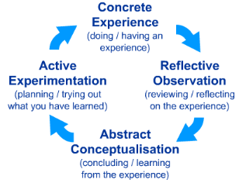
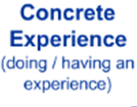
This leads to the next cycle of learning

A simpler way of looking at this cycle is see, do and review importantly the review must link onto the next cycle, when we plan in school we use the terms intention, implementation and impact.

The cycle fits pupils in a class, the teacher managing the class, the school managing all classes and Eden Academy Trust managing all the Schools in our Trust.

Marking will provide a motivational force for pupils, celebrate their achievement and move their learning forward.

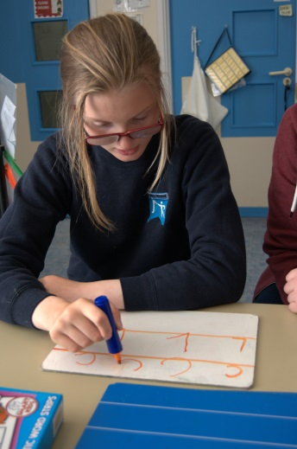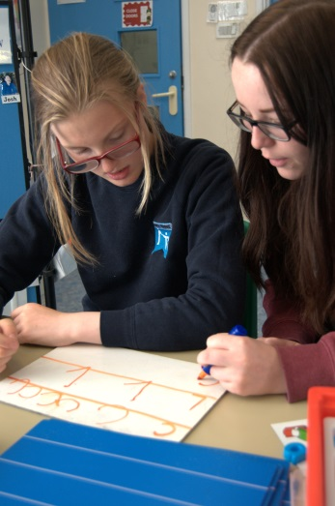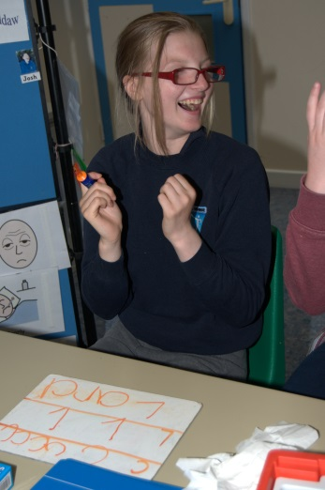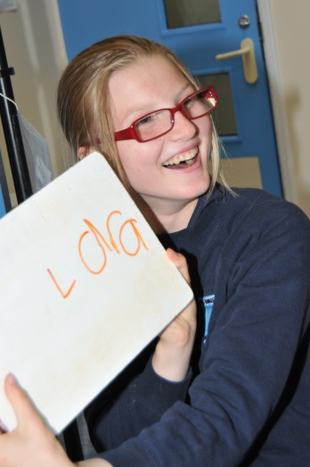
Success!
Trying out what you’ve learnt
Trying something from previous knowledge
Reflecting & learning through marking

How do we mark?

The key message is that we do not mark in one single way; we mark according to the pupil and the learning situation. The format of marking will be down to professional judgement; marking is not just about keeping records it is about learning. For many pupils a combination of marking strategies will be needed and used for each learning experience.

It is important that steps for each learning cycle are broken down to the point where the steps are understandable and achievable for the individual (this does not mean the steps should not be challenging). For example, we may want a pupil to write their name, but if they cannot form each of the letters then the ultimate goal of writing their name could be viewed as unachievable leading to fear of failure and disengagement with learning.

- Body language

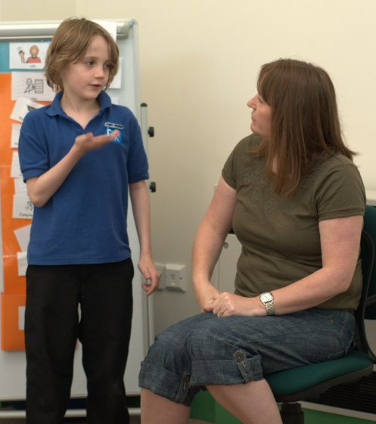
For many pupils in all parts of our school community, body language can be seen as a building block of marking as it forms a foundation for communication; additionally with unthoughtful or ill-conceived body language a pupil’s receptive skills may reduce dramatically and so will their learning.

Depending on the pupil, the learning environment and the point in time, body language should reflect the learner’s needs. For some pupils this will mean exuberant and exaggerated body movements to give positive feedback, for others it will mean a slow a subtle shifting of position or a spreading grin. Much will depend on the individuals’ relationship with others.

We cannot write a policy to tell people what body language to use as this depends on the individuals involved, but we can have a policy that states we should consider at all times what our body language says to a pupil. Going further if body language is a primary driver for communication all staff should consider using others eyes or video to provide themselves with feedback as to the effectiveness of signals they are using.

- Touch

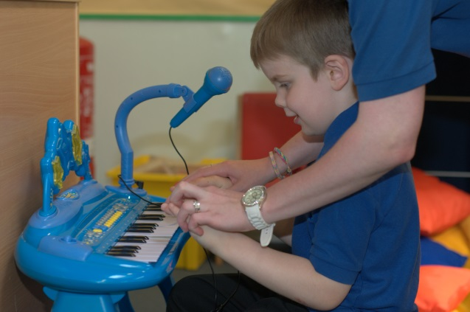
For some pupils, tactile feedback is an essential part of marking; it gives them an understanding of what they need to do as they are guided in new experiences. This will in particular be true for pupils with poor praxis or coordination difficulties where they do not yet have the necessary motor control to provide their own reliable feedback loops.

For some pupils touch provides emotional reassurance as they encounter new or challenging experiences; this should be noted as our pupils are often not just learning about the academic task in front of them but also about the world around them, including social and environmental interaction. For pupils at a low developmental level or for those that have sensory processing difficulties (pupils with ASC for example)tactile feedback (or marking) will be required additionally so they can access their lessons work.

Touch, especially gross muscle pressure can provide an important part of positive reinforcement during marking, especially for pupils with ASC where other forms of praise are not yet able to be understood.
As pupils develop it may be necessary to teach them alternatives to touch as a way of marking, so they can engage in age and socially appropriate ways of learning.

- The spoken word

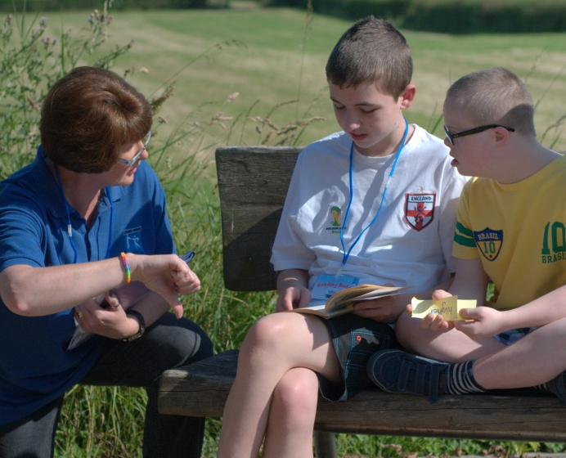
The spoken word in marking is hugely important for our pupils but also one of the most complex as the nuances of language, similes and metaphor can cloud the message a pupil gets. It should also be reflected upon that the spoken word does not just mean the words themselves, but also the tone, pitch and volume – it is these which many pupils will pick up upon prior to understanding the content of the words themselves.

Tone, pitch and volume are the first areas to be taken into account; Using strategies such as Intensive Interaction with pupils with more complex communication needs will allow them to learn better this will involve the professional repeating and adding verbal (also physical) cues to those given by the pupil.

Again it is difficult to write a policy that states exactly what kind of tone, pitch and volume to use with pupils as the effect of these will vary from pupil to pupil; however staff should consider 3 things linked to these variables –
1) What change in these provides positive reinforcement?
2) What change in these provide in these provides negative reinforcement?
3) What change in these will result in over-stimulation (and therefore a reduction in learning capacity)?

Where a pupil has an understanding of language 5 key principles should be used when marking verbally
- Use simple, clear language the pupil can understand
- Use the pupil’s name
- Make the verbal marking positive
- Tell the pupil what they’ve done correctly – praising the process not just the outcome
- Tell them or ask them a question so they can make the next step

Sally 2 + 2 is 4, you’ve thought that addition out really well. What did you do to get that answer…………. So how are we going to add 2 + 3?

Praising the process not just the outcome is an essential part of learning, such principles can be seen in the writing of C Dweck (Mindset; The psychology of success 2006).

Keeping verbal language objective and without simile or metaphor is hugely important to our pupils, particular those with ASC because our pupils will often take verbal messages as their literal rather than their symbolic meaning. Take for example the literal interpretation of James you are on fire this morning or Bridgette you are as bright as a button. If you are to use such phrases teach their meaning first then use them (this will also add to pupils’ social understanding knowledge and skills).

- Symbolic Marking
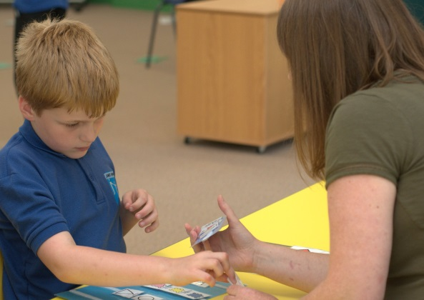
At James Rennie School we use PECS (Picture Exchange Communication System) as a scaffolded process for communication. It supports other communication systems for pupils. We use 3 key symbols across School when looking at how a pupil has achieved.

 |  | 
I need to revisit this task |  | I achieved this task with support |  | I Achieved this task independently

We use the symbols in different situations, but they give both pupils and staff a quick visual guide to task achievement. The symbols in themselves are only symbols of achievement of a task; it does not provide the crucial next step for the pupil.

We use these symbols as stickers to be attached to work or to be given to pupils directly, and these should be used in pupils work files on a daily basis.

For more able pupils they may form part of written objectives, where pupils can mark themselves.

What do I need to learn | 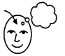 | How have I done this week |  | 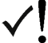 | Week | 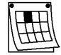
Count on in 10’s from 0 - 100 |  |  |  |  | 1
Count back in 10’s from 100 - 0
Write down 10 times table
Comments

This kind of form may be integrated into worksheets, used as a start / plenary point, or extended over a number of weeks so pupils can see their own progress over time. It should be noted a key part of the table is the comments section, within this should be context to the learning and the next step, for example.
Jilly could not count on in tens without verbal support, however there was building work outside and she was distracted. If this continues next lesson use the library where it will be quieter

This visual scaffold to support learning, will support pupils with ASC significantly and it may be needed to be continued even when the individuals understanding of text would appear to be beyond this step.

Care must be taken with these symbols, that they are not seen or used negatively. If a pupil comes to associate a red sticker with failure or other negative connotations then they will come to fear revisiting work and so learning itself. Key to this philosophy is helping pupils to understand that learning is a process and not about the outcome
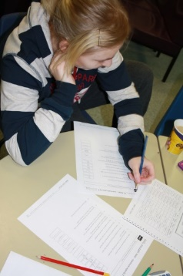
- Written Marking

This section covers specifically written marking on pupils work (teacher written records follow this section).

Anecdotally some of our pupils find written annotations both their own and others challenging. This may be because they perceive it as something which is concrete evidence of failure, such pupils may attempt to rub out or destroy their work, followed quickly by disengagement. So staff must balance this against the gains that come from written annotations, further it will be necessary to teach our pupils why written annotations are important (this may take years in some cases) and use them positively at all times.

Pupils own written annotations in conjunction with a member of staff will help the pupil explain their understanding, will provide them with an understanding of their own thought processes. This will give then a concrete place from which to make the next step. A pupil’s own annotation will also provide the teacher with a view on how to adjust the pupil’s next step.
Staff annotation should provide the pupil with concrete knowledge of their progress and attainment; importantly it should also enable the pupil to make the next step in learning either through modelling or by inference from comments.

Written feedback should follow exactly the same principles as verbal feedback so that pupils can make best progress.

For both pupil and staff annotation may be aided by using a different colour of pen or pencil so that it can be clearly identified. If it makes a difference to the pupil then the colour of annotation could be a negotiated so that pupils have positive ownership of the process.

- Next steps
In each of the feedback models ensuring pupils are part of the decision making process in the next cycle of learning is essential, the teacher plays a crucial role in giving pupils the confidence to step up to new unfamiliar learning. Teachers should have in the front of their minds that each time a pupil moves to a new level of learning we are promoting them from a point of competence to incompetence, and that positive emotional support will be needed in order to achieve this step effectively.

For some pupils enthusiasm to push too far, will need to be tempered and harnessed by the teacher so the next step will be achieved, for other pupils reticence about new experiences or tasks will need to be equally supported (this is particularly true for pupils with ASC).

- Teacher written records

Teacher written records are in place to allow the teacher to judge progress and alter tasks in or order that a pupil can gain the best possible attainment; as such the style of recording should reflect the pupil’s attainment levels. In terms of style of recording the teacher should show a clear learning objective and then pupils progress towards this objective.

There should be freedom within the recording system used to enable the teacher to alter objectives over a time period; comments on the objectives should leave no room for interpretation.

Staff must when recording reflect on what their notes objectively mean; take the two tables below as examples, one works much better than the other.

Objective | Comment |  |  |  |  | Date
Count to 10 | Bobby hated counting using red counters |  |  | ✓ |  | 7th October
Count to 10 | Bobby enjoyed counting with counters but needed some help |  |  | ✓ |  | 14th October
Count to 10 | Bobby still wanted to use blue counters and still needed help |  |  | ✓ |  | 21st October

With this example the teacher talks about what Bobby enjoyed / hated which was useful in the first week as the colour of counters was providing a barrier to learning, but there is no comment on the process of counting , the teacher is not thinking about the next step which should be linked to the learning objective.

Objective | Comment |  | Support needed | Date
Form letter ‘l’ independently | Drawing ‘l’ from base to top, need to model for each repetition |  | No support – copied pre written letters – baseline exercise | 10th October
Form letter ‘l’ independently | Able copy ‘l’ from top to bottom after modelling, but could not differentiate her own letter use a different colored pens for pupil and teacher |  | Modelled 1 letter at a time, then Sally copied letter | 12th October
Form letter ‘l’ independently | Copied again after modelling this time able to spot her own letters. Struggled to keep letters on line – focus for next lesson |  | Modelled 1 letter at a time, then Sally copied letter | 15th October

With this example the teacher shows what the pupil achieved in relation to the objective and precisely what the next step should be. The comments must have their roots in the learning observed.

- Summative Marking

There is a need to mark a pupil’s attainment at a place in time; this may be so attainment can be judged over a period of time, to evaluate learning strategies, to provide a picture of the pupil to others, for accreditation etc.

When we mark for this purpose it should be linked to key criteria such as Curriculum levels or exam objectives, this should be clear for the intended audience, and for teachers it’s important not to just to teach to this criteria as this will limit learning and endanger the application of the learning, i.e. our marking must follow and inform what pupils are learning and lead what they are learning.

We use SOLAR, an on-line database which can include any marking criteria, it allows us aggregate progress across the school and to analyse this process.

Assessment should be linked to key pieces of a pupil’s work, and annotations should only describe what has been achieved not the emotions attached to the achievement. e.g. Billy tied his shoe laces, with verbal support to scaffold the crossing of laces and not Billy tried really hard to tie his laces, and was pleased when I told what to do.

Teachers can mark attainment at any time during the year, but we draw down on the marks at every half term to evaluate attainment at this time and for key subjects progress is moderated, challenged and supported by the Deputy Head.

Key subject progression measures are evaluated annually in July and will be fed into the following years development plan in the following September.

For other subjects teachers will mark progress with a piece of work that best describes attainment for the subject just prior to Christmas, Easter and summer holidays. For each of these pieces of work there will be a clear indicator of attainment, and should be linked in to the Intentions of Planning set at the beginning of the term.

- Qualitative and Quantitative Marking
It is important to understand that as a School we use both measures, when and where we use them will be dependent on what is being marked.
Quantitative marking will be used when a binary target is used, i.e. when something is or is not achieved, e.g. Billy will write his name in cursive script without support.
Whilst qualitative marking will be used when a target is broader and tends to be focussed on the quality of a process, e.g. Sally will dress without support after swimming.

- How do we moderate and check our marking
As a school, we moderate our marking and understanding of pupil of practise to ensure what we are seeing is the truest picture of pupil progress, because without this we cannot be sure the next steps in learning for pupils are the most appropriate, (this includes by definition the correct strategies too).

Moderation may take place as part of classroom observations, termly meeting with the deputy head teacher, whole school moderation or external moderation of school processes.

Moderation allows checking of accuracy, processes and outcomes.

References

Kolb, D. A. (1984). Experiential learning: Experience as the source of learning and development (Vol. 1). Englewood Cliffs, NJ: Prentice-Hall.

Dweck, C. S. (2006). Mindset: The new psychology of success. New York: Random House.

