
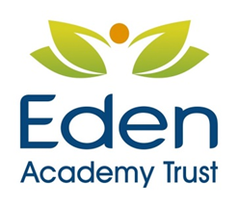

Catering Assistant Required
Job reference JTS/CA01/22
NJC 1 7.5 hours/week plus inset days

Due to the retirement of a member of staff. We are looking for an enthusiastic and hard working individual to be a catering assistant at our school. You should have experience of working with children and working in a kitchen. You would be joining an established team of dedicated individuals who provide an outstanding service over the lunchtime period. NVQ2 in food hygiene preferable. All candidates must be prepared to undertake all training required to meet our rigorous standards of health and safety and hygiene to ensure a premium service for both staff and students.

Your hours of work would be 7.5 per week term time only with an annual salary of £3,175.00 If you would like to join our team please request an application pack at:
office@jamesrennie.cumbria.sch.uk or by telephone on 01228 554280

Closing date is: 14 January 2022
Interviews will take place week commencing: 17 January 2022

James Rennie School is committed to safeguarding and promoting the welfare of children and young people and expects all staff and volunteers to share this commitment. Therefore, an enhanced DBS check including the barred list will be required for the successful candidate and other procedures and checks will be followed as laid out in our Safeguarding Policy.

